OPERATING SYSTEMS
Chapter 8: DEADLOCKS
Complete University Exam Notes
Topics Covered
System Model • Deadlock Characterization • Four Necessary Conditions
Resource Allocation Graphs • Handling Methods • Prevention Strategies
Ostrich Algorithm • Resource Ordering • Recovery Techniques
Based on: Operating System Concepts – 9th Edition (Silberschatz, Galvin & Gagne)

1. System Model

1.1 Definition
A system model describes how processes use resources in an operating system. Before a process can use a resource, it must request it. After using it, it must release it.

1.2 Key Components
- The system has many types of resources.
- Resources include: CPU cycles, memory space, I/O devices (like printers, disks).
- Each resource type Ri has Wi instances (copies).
- Example: If there are 3 printers, the printer resource type has 3 instances.

1.3 How a Process Uses a Resource (3 Steps)
Step | Action | Description
Step 1 | Request | Process asks the OS for the resource. If not available, process waits.
Step 2 | Use | Process uses the resource to do its work.
Step 3 | Release | Process finishes and gives back the resource to OS.

⭐ Important Exam Points
- Resource types: R1, R2, ..., Rm
- Each type has Wi instances
- Three steps: Request → Use → Release

2. Deadlock

2.1 Definition
A deadlock is a situation where two or more processes are waiting for each other to release resources — but none of them ever will. All processes are stuck permanently.

2.2 Simple Real-Life Analogy
- Two cars on a narrow one-lane road facing each other.
- Neither can move forward. Neither will reverse. Both are stuck.
- This is exactly like a deadlock in OS.

2.3 Classic OS Example
Program 1 requests Resource A and receives it.
Program 2 requests Resource B and receives it.
Program 1 requests Resource B — WAITS (B held by Program 2).
Program 2 requests Resource A — WAITS (A held by Program 1).
Result: Both programs wait forever. DEADLOCK!

3. Deadlock Characterization — Four Necessary Conditions

Deadlock can ONLY happen when ALL FOUR conditions hold at the same time. If even ONE condition is missing → NO deadlock.

3.1 The Four Coffman Conditions
# | Condition | Simple Meaning
1 | Mutual Exclusion | Only ONE process can use a resource at a time. Others must wait.
2 | Hold and Wait | A process holds one resource AND is waiting to get more.
3 | No Preemption | Resources cannot be forcibly taken away. A process releases voluntarily.
4 | Circular Wait | Process A waits for B, B waits for C, C waits for A — a circle!

3.2 Mutual Exclusion — Detailed
- Only one process can use a resource at any given time.
- Non-sharable resources: like a printer — only one process prints at a time.
- Sharable resources: like read-only files — many processes can read at the same time.
- Mutual exclusion is NEEDED for non-sharable resources.

3.3 Hold and Wait — Detailed
- Process holds at least 1 resource.
- At the same time, it is waiting to get additional resources held by other processes.
- Example: A process holds a printer but is waiting for a scanner.

3.4 No Preemption — Detailed
- OS cannot forcibly take a resource from a process.
- The process must voluntarily release it after completing its task.
- Example: A process printing cannot have the printer snatched away mid-print.

3.5 Circular Wait — Detailed
- A set of processes {P0, P1, P2, ..., Pn} where:
  - P0 waits for a resource held by P1
  - P1 waits for a resource held by P2
  - ... and so on ...
  - Pn waits for a resource held by P0 → CIRCLE!

⭐ KEY RULE: ALL 4 conditions must exist together for deadlock. Prevent even ONE → No deadlock!

4. Resource Allocation Graph (RAG)

4.1 Definition
A Resource Allocation Graph (RAG) is a directed graph used to describe the state of resource allocation in a system. It shows which process holds which resource and which process is waiting for which resource.

4.2 Components of RAG
Component | Symbol | Description
Process | Circle (Pi) | Represents a process in the system
Resource Type | Rectangle (Rj) | Represents a type of resource; dots inside = instances
Request Edge | Pi → Rj | Process Pi is requesting (waiting for) resource Rj
Assignment Edge | Rj → Pi | Resource Rj is assigned to (held by) process Pi

4.3 Request Edge vs Assignment Edge
Type | Direction | Meaning | Example
Request Edge | Process → Resource | Process is WAITING for the resource | P1 → R1 means P1 wants R1
Assignment Edge | Resource → Process | Resource is GIVEN to the process | R1 → P1 means R1 is held by P1

4.4 Diagram Reference
Example of a Resource Allocation Graph]
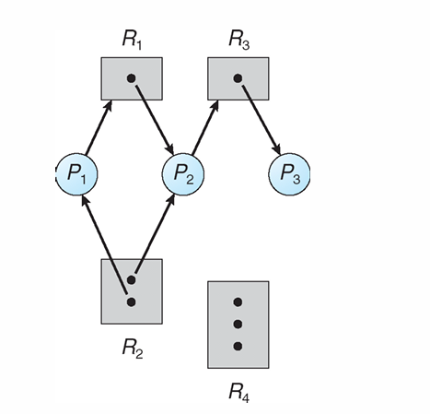
The diagram shows processes P1, P2, P3 and resources R1, R2, R3, R4 with request and assignment edges.

Resource Allocation Graph With A Deadlock]
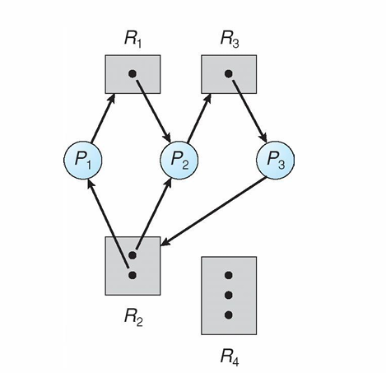
This diagram shows a cycle forming between processes and resources, causing a deadlock situation.

Graph With A Cycle But No Deadlock]
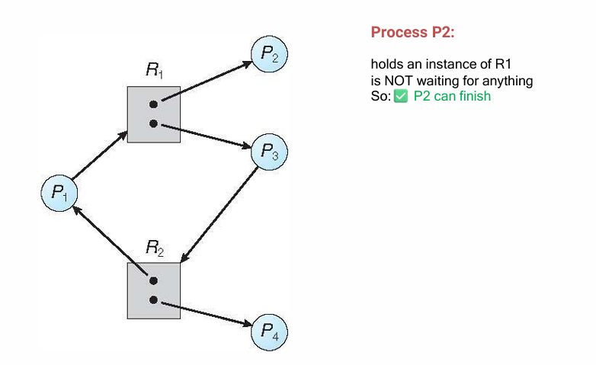
This shows a cycle exists but Process P2 (which holds R1) is NOT waiting → P2 can finish → releases R1 → cycle breaks → NO deadlock.

5. Basic Facts About Deadlock and RAG

Situation | Conclusion
Graph has NO cycle | → DEFINITELY NO DEADLOCK
Graph has a cycle + only 1 instance per resource | → DEFINITELY DEADLOCK
Graph has a cycle + multiple instances per resource | → POSSIBLE DEADLOCK (not guaranteed)

5.1 Cycle vs Deadlock — Common Confusion Explained
- A cycle in RAG does NOT always mean deadlock.
- If resources have multiple instances, a process outside the cycle might finish and release a resource.
- That released resource can break the cycle → No deadlock.
- Single instance resources: Cycle = Deadlock (always).
- Multiple instance resources: Cycle = Possible Deadlock (check carefully).

⭐ Exam Tip: Cycle is NECESSARY but not SUFFICIENT for deadlock (when multiple instances exist).

6. Methods for Handling Deadlocks

6.1 Three Main Approaches
Approach | Strategy | Used In
Prevention / Avoidance | Ensure system NEVER enters deadlock state | High safety systems
Detection + Recovery | Allow deadlock to occur, then detect and recover | General purpose OS
Ignore (Ostrich Algorithm) | Pretend deadlocks don't exist | UNIX, Windows (rare deadlocks)

6.2 Ostrich Algorithm
The Ostrich Algorithm = IGNORE the deadlock problem completely. Just like an ostrich burying its head in the sand and pretending there is no danger.

- Assumption: Deadlocks are so rare that preventing them is not worth the cost.
- If deadlock happens → OS reboots to recover.
- Used by: UNIX, Windows (in practice).
- Reason: Deadlocks happen very rarely in real systems.
- Trade-off: Saves resources in normal operation; can cause problems when deadlock occurs.

⭐ Exam Points
- Ostrich = Ignore + Reboot approach
- Used when deadlocks are rare and prevention cost is too high
- NOT the safest option but MOST practical for general-purpose OS

7. Deadlock Prevention

Deadlock Prevention = Make sure at least ONE of the four necessary conditions CANNOT happen. If one condition is blocked → Deadlock is impossible!

7.1 Overview of Prevention Methods
Condition to Attack | Method Used | Result
Mutual Exclusion | Make resources sharable (spooling) | Fewer exclusive locks
Hold and Wait | Request all resources upfront OR release before new request | No holding while waiting
No Preemption | Allow resource preemption / virtualization | OS can take resources back
Circular Wait | Assign resource ordering / numbering | No cycles possible

7.2 Attacking Mutual Exclusion

Idea
- If resources can be shared, processes don't need exclusive access.
- Sharing reduces waiting and eliminates the mutual exclusion condition.

Printer Spooling — Key Example
Concept | Explanation
Problem | If two processes directly access a printer → conflict
Solution | Spooling: Processes write to a disk spool file, not directly to printer
Printer Daemon | A background program reads the spool file and prints one job at a time
Advantage | Multiple processes can 'use' printer simultaneously (via spool)
Limitation | Some resources CANNOT be made sharable (e.g., two processes writing to same file simultaneously causes corruption)

Read-Only Files Example
- Multiple processes can read the same file at the same time.
- No conflict because no one is writing.
- Mutual exclusion not needed for read-only access.

⭐ Limitation: Cannot eliminate mutual exclusion for all resources. Some resources like printers, locks, database records must remain exclusive.

7.3 Attacking Hold and Wait

Method 1: Request All Resources Before Execution Starts
- Process must request ALL resources it will ever need BEFORE it starts running.
- If ALL resources are available → Allocate all and let process run.
- If even ONE resource is not available → Process waits (holding nothing).

Advantages | Disadvantages
Eliminates hold-and-wait completely | Poor resource utilization
Simple to implement | Processes may not know all future resource needs
Prevents deadlock | Resources are held unnecessarily for a long time
 | Starvation possible (process may wait forever if popular resources always busy)

Method 2 (Alternative): Release Before Requesting
- If a process needs a new resource, it must FIRST release all resources it currently holds.
- Then it requests everything it needs again.

Step | Action
1 | Process releases ALL currently held resources
2 | Process requests ALL resources it needs (old + new)
3 | If all available → allocate and run. If not → keep waiting.

- Advantage: Eliminates circular dependency.
- Disadvantage: Frequent releasing/reacquiring causes overhead and inefficiency.

7.4 Attacking No Preemption

Normally, resources cannot be forcibly taken from a process. Attacking this condition means allowing the OS to take (preempt) resources when needed.

Approach: Virtualization
- Instead of directly using hardware, create a virtual version.
- Example: Printer Spooling — processes write to virtual printer (disk spool), not real printer.
- Printer daemon manages the real printer without conflict.

Aspect | Details
Advantage | Reduces direct contention for physical hardware
Limitation | Not all resources can be virtualized
Cannot Virtualize | Database records, OS tables — they must be locked for use, and locking itself can cause deadlock
Safe to Virtualize | Printers, plotters, display devices (via spooling)

7.5 Attacking Circular Wait

This is the MOST PRACTICAL prevention method. The idea is to prevent any circular chain of waiting from forming.

Method 1: One Resource at a Time
- A process may hold only ONE resource at a time.
- If it needs another resource, it must first release the current one.
- Limitation: Impractical for many real tasks.
- Example: Copying from tape drive to printer — needs BOTH simultaneously. Cannot work with one at a time.

Method 2: Resource Ordering (Most Important!)
Assign a unique number to every resource type. Processes must request resources ONLY in increasing order of their numbers.

7.6 Resource Ordering Technique — Detailed

How It Works
Resource | Assigned Number
Imagesetter | 1
Printer | 2
Plotter | 3
Tape Drive | 4
Blu-ray Drive | 5

Rule
A process can only request resource Rj if Rj's number is GREATER than the number of ANY resource currently held.

Examples
Request | Allowed? | Reason
Printer (2) → Tape Drive (4) | ✅ ALLOWED | 4 > 2, increasing order
Plotter (3) → Printer (2) | ❌ NOT ALLOWED | 2 < 3, decreasing order, must release Plotter first
Tape Drive (4) → Blu-ray (5) | ✅ ALLOWED | 5 > 4, increasing order

Why Does This Prevent Circular Wait?
Proof by contradiction:
• Suppose Process A holds resource i and waits for resource j (j > i — required by rule)
• For a cycle, Process B must hold j and wait for i
• But i < j → Process B cannot request i (it would be requesting LOWER numbered resource)
• CONTRADICTION! → No cycle can form → No circular wait → No deadlock

Aspect | Details
Advantage | Effective — completely eliminates circular wait. Relatively easy to implement.
Disadvantage | Resource numbering must be carefully planned. Processes must know resource order in advance.
Key Point | No cycle = No deadlock (guaranteed)

8. ONE PAGE QUICK REVISION SHEET

Topic | Key Points
Deadlock | Two+ processes waiting for each other's resources. No one moves. All stuck permanently.
4 Conditions | Mutual Exclusion + Hold & Wait + No Preemption + Circular Wait (ALL must hold)
RAG Request Edge | Process → Resource (process is WAITING)
RAG Assignment Edge | Resource → Process (resource is HELD)
Cycle + 1 instance | = Definite DEADLOCK
Cycle + multiple instances | = Possible deadlock (check if any process can finish)
Ostrich Algorithm | Ignore deadlocks; reboot if it happens; used in UNIX/Windows
Prevention: Mutual Excl. | Use spooling (printer daemon); make resources sharable
Prevention: Hold & Wait | Request all resources before starting OR release all before requesting more
Prevention: No Preemption | Virtualize resources (spooling); OS can reclaim virtualized resources
Prevention: Circular Wait | Assign numbers to resources; always request in increasing order

9. Important Definitions Table

Term | Definition
Deadlock | A permanent standstill where processes wait for resources held by each other.
Resource Instance | A single copy of a resource type (e.g., one of three printers).
Mutual Exclusion | Only one process can use a non-sharable resource at a time.
Hold and Wait | A process holds resources while waiting to acquire more.
No Preemption | Resources cannot be forcibly taken; only voluntarily released.
Circular Wait | A circular chain of processes each waiting for a resource held by the next.
RAG | Resource Allocation Graph — directed graph showing resource allocation state.
Request Edge | Directed edge from Process to Resource — process is waiting for resource.
Assignment Edge | Directed edge from Resource to Process — process holds the resource.
Ostrich Algorithm | Strategy of ignoring deadlocks; assume they are rare enough to ignore.
Spooling | Technique where process output is stored on disk; daemon handles actual device.
Resource Ordering | Assigning numbers to resources and requiring requests in increasing order.
Starvation | A process waits indefinitely because resources are always taken by others.
Preemption | Forcibly removing a resource from a process (used in prevention).
Safe State | System state where a safe sequence exists and deadlock can be avoided.

10. Important Comparison Tables

10.1 Three Methods to Handle Deadlock
Method | Description | Advantage | Disadvantage
Prevention | Eliminate one of 4 conditions | Guaranteed no deadlock | Low resource utilization
Detection + Recovery | Allow deadlock, then fix it | Better resource use | Recovery cost, may lose work
Ignorance (Ostrich) | Ignore deadlocks completely | No overhead | System may crash or freeze

10.2 Prevention Methods Comparison
Condition Attacked | Method | Advantage | Disadvantage
Mutual Exclusion | Spooling, sharing | Reduces conflicts | Cannot work for all resources
Hold and Wait (M1) | Request all resources initially | Simple, no hold+wait | Poor utilization, starvation
Hold and Wait (M2) | Release before new request | Eliminates circular deps | Overhead, inefficiency
No Preemption | Virtualization/spooling | Reduces contention | Cannot virtualize all resources
Circular Wait | Resource ordering by number | Very effective | Needs careful planning

10.3 Cycle in RAG — Deadlock or Not?
Resource Instances | Cycle Present? | Deadlock?
Single instance per type | YES | DEFINITELY YES
Single instance per type | NO | DEFINITELY NO
Multiple instances per type | YES | POSSIBLY (check if any process can finish)
Multiple instances per type | NO | DEFINITELY NO

11. Four Conditions Summary Table

Condition | Meaning | Prevention Strategy | Example
Mutual Exclusion | Only 1 process uses resource at a time | Spooling; sharing read-only files | Printer: only 1 process prints
Hold and Wait | Process holds resource + waits for more | Request all at start OR release all first | P holds printer, wants scanner
No Preemption | Resources cannot be forcibly removed | Virtualize resources; preempt if needed | Printing: cannot interrupt mid-page
Circular Wait | Processes wait in a circle for resources | Number resources; request in order only | P1→R1→P2→R2→P1 (cycle)

12. Possible Viva Questions

Question | Short Answer
What is a deadlock? | A state where processes wait for each other's resources indefinitely.
What are the 4 conditions for deadlock? | Mutual Exclusion, Hold & Wait, No Preemption, Circular Wait.
What is the Ostrich Algorithm? | Ignore deadlocks; assume they are rare. Used in UNIX/Windows.
What is a RAG? | Resource Allocation Graph — shows which process holds/waits for which resource.
What is a request edge? | An edge from process to resource — process is waiting for that resource.
What is an assignment edge? | An edge from resource to process — process holds that resource.
Does a cycle in RAG always mean deadlock? | No. Only if each resource has 1 instance. Multiple instances = possible but not certain.
How does resource ordering prevent deadlock? | By requiring requests in increasing order, no circular chain can form.
What is spooling? How does it help? | Jobs are written to disk; daemon prints them. Multiple processes share printer without conflict.
What is Hold & Wait prevention Method 2? | Release ALL resources before requesting any new ones.

13. Possible Exam Questions

13.1 Short Questions (2–5 marks)
- Define deadlock. Give one example.
- State the four necessary conditions for deadlock.
- What is the Ostrich Algorithm? When is it used?
- Differentiate between request edge and assignment edge in RAG.
- What are the basic facts about cycles in a RAG?
- Explain printer spooling and its role in deadlock prevention.
- What is resource ordering? Give an example.
- State any two methods to handle deadlocks.

13.2 Broad / Long Questions (10–15 marks)
- Explain the four necessary conditions for deadlock with examples.
- Explain Resource Allocation Graph with diagrams. When does a cycle indicate a deadlock?
- Explain all methods of Deadlock Prevention in detail.
- Compare and contrast the three approaches to handling deadlocks.
- Explain how attacking the Circular Wait condition prevents deadlock. Give a proof.
- What is the Hold and Wait condition? Give two methods to prevent it. Compare their advantages and disadvantages.

13.3 Common Tricky Exam Questions
Tricky Question | Correct Answer
Can a deadlock occur with only 2 processes? | YES — if they each hold one resource and request the other.
Does every cycle in RAG mean deadlock? | NO — only if each resource has exactly 1 instance.
Is Ostrich Algorithm the best strategy? | No — it's practical for rare deadlocks but not safe in critical systems.
If we prevent Circular Wait, is deadlock impossible? | YES — because all 4 conditions must hold; removing one prevents deadlock.
Can spooling prevent deadlock for all resources? | No — only for resources that can be virtualized (like printers).
Is starvation the same as deadlock? | No — in starvation, a process waits a long time but may eventually run. In deadlock, it waits forever.

14. Final Summary — Everything in One Place

DEADLOCK AT A GLANCE
Deadlock = Permanent standstill of processes waiting for resources.
4 Conditions (ALL must hold): Mutual Exclusion + Hold & Wait + No Preemption + Circular Wait
3 Handling Methods: Prevention | Detection & Recovery | Ignore (Ostrich)
RAG: No cycle = No deadlock. Cycle + 1 instance = Deadlock. Cycle + multiple = Possible.
Best Prevention = Resource Ordering (assign numbers, request in increasing order only).
Spooling = processes write to disk spool, daemon handles actual device. Reduces conflict.

Good Luck on Your Exam! 🎓
Operating System Concepts – Chapter 8: Deadlocks

